Project Performance Test

Date | 10 july 2026
Team ID
Project Name | Project -strategic product placement analysis
Maximum Marks

Model Performance Testing:
Project team shall fill the following information in model performance testing template.
S.No. | Parameter | Screenshot / Values
 | Data Rendered | Product Placement dataset successfully loaded and rendered in Tableau.  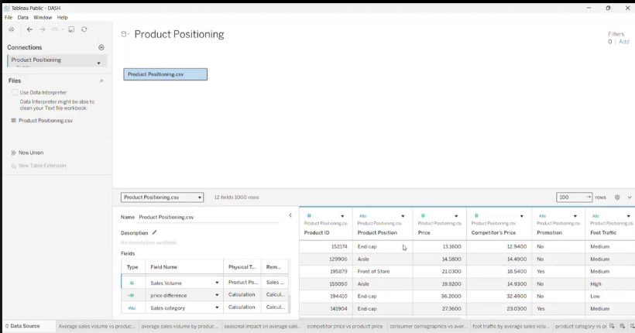
 | Data Preprocessing | Missing values removed, duplicate records handled, data formatted, and calculated fields created.  • Dataset loaded into Tableau  • Missing values checked  • Duplicates removed  • Data types verified  • Column names formatted  • Data validated before visualization
3. | Utilization of Filters | Filters used: Product Category, Season, Promotion, Consumer Demographics, Foot Traffic.  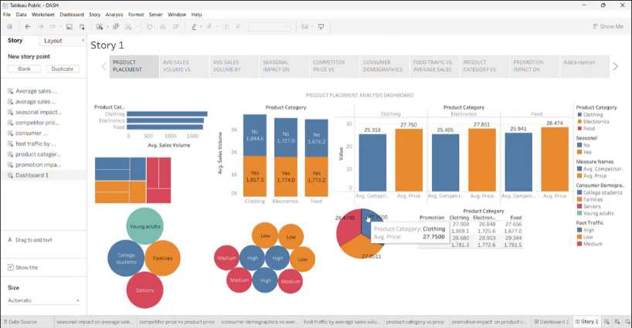
4. | Calculation fields Used | • AVG(Sales Volume)  • AVG(Price)  • AVG(Competitor Price)  • Price Difference = Price − Competitor Price  • Promotion Impact = IF Promotion = "Yes" THEN Sales Volume ELSE 0 END
5. | Dashboard design | No of Visualizations / Graphs -: 8  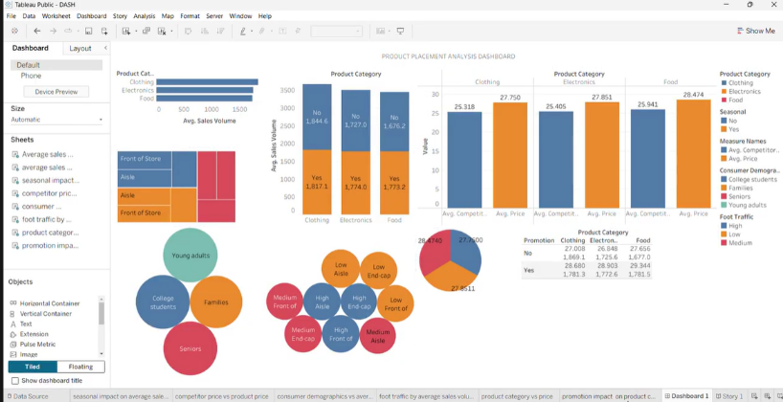
6 | Story Design | No of Visualizations / Graphs -9 (8 Visualizations + 1 Dashboard)

